Test Case: tc006_SPX_Dev5_Crear_Requisicion_Spot_Tipo_Cobro_Proyect_Urgent
Step 1 - Enter username and password and click to button Enter: Credentials Entered
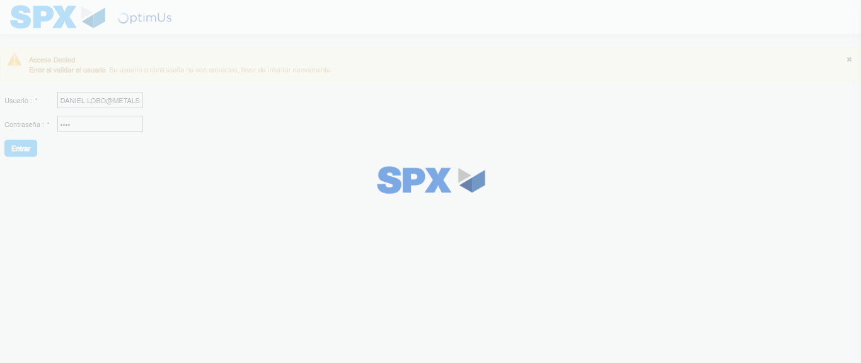Image file-name: QC_Testing-tc006_SPX_Dev5_Crear_Requisicion_Spot_Tipo_Cobro_Proyect_Urgent-1784214682015

Step 2 - Select to UEN and Access to Spot Buy Requisitions : UEN Correctly selected and Correct access
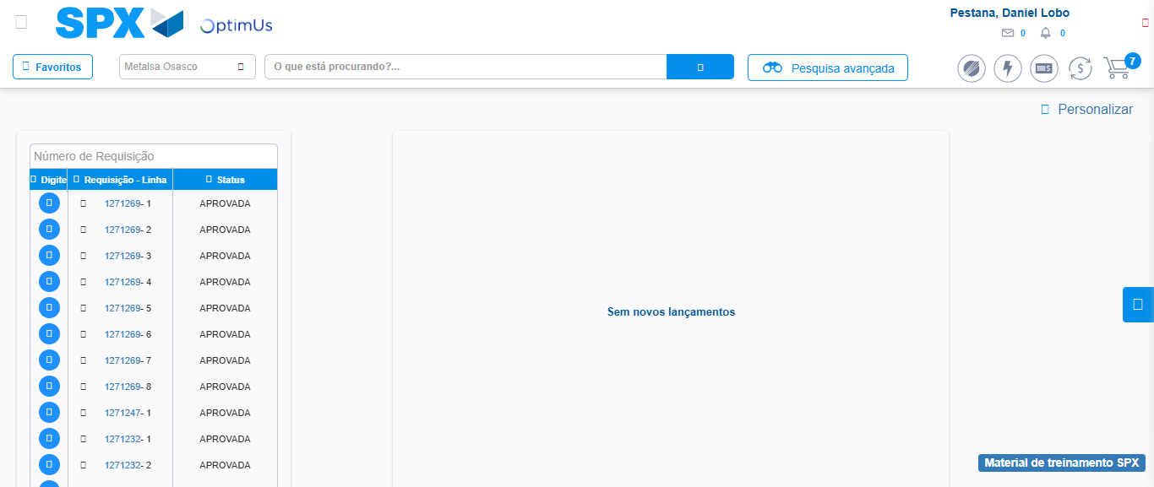Image file-name: QC_Testing-tc006_SPX_Dev5_Crear_Requisicion_Spot_Tipo_Cobro_Proyect_Urgent-1784214710823

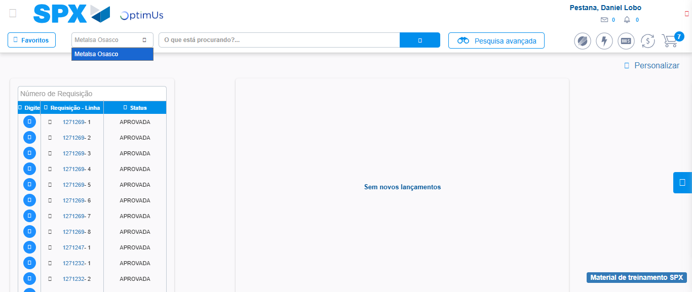Image file-name: QC_Testing-tc006_SPX_Dev5_Crear_Requisicion_Spot_Tipo_Cobro_Proyect_Urgent-1784214713371

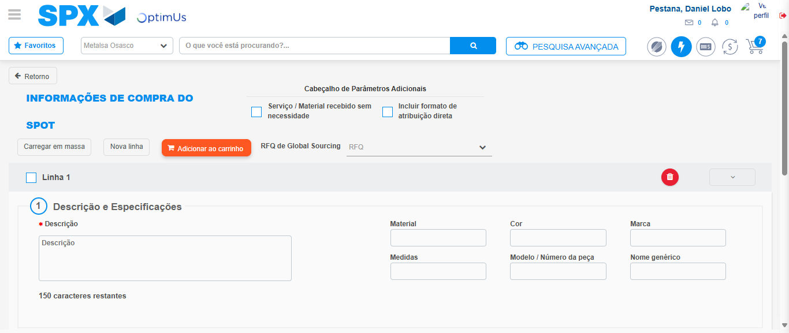Image file-name: QC_Testing-tc006_SPX_Dev5_Crear_Requisicion_Spot_Tipo_Cobro_Proyect_Urgent-1784214731292

Step 3 - Data Capture Spot Buy Requisition: Data captured correctly
Image file-name: QC_Testing-tc006_SPX_Dev5_Crear_Requisicion_Spot_Tipo_Cobro_Proyect_Urgent-1784214731602

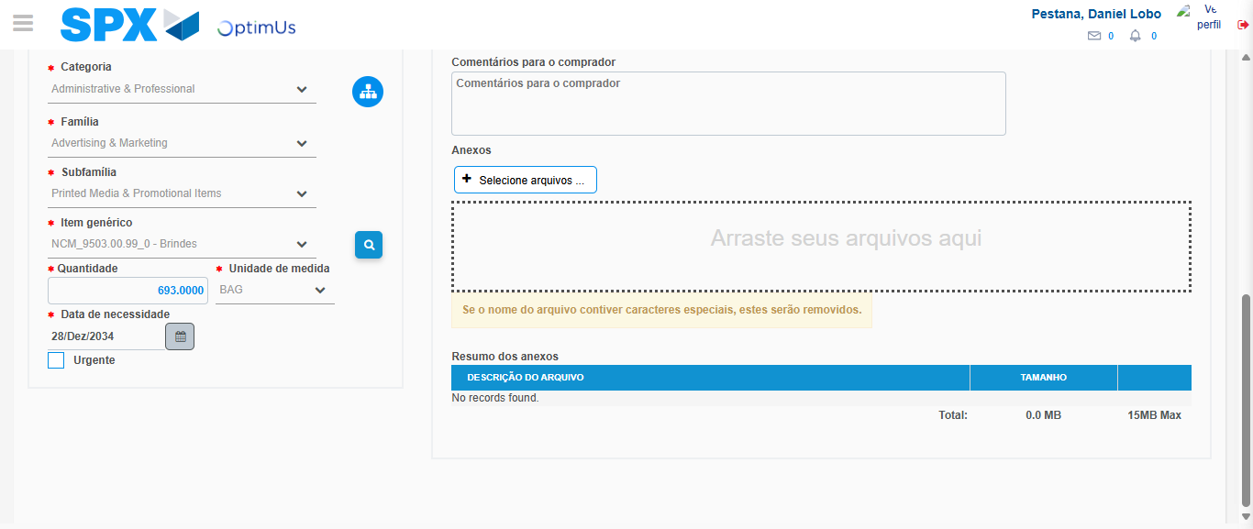Image file-name: QC_Testing-tc006_SPX_Dev5_Crear_Requisicion_Spot_Tipo_Cobro_Proyect_Urgent-1784214746433

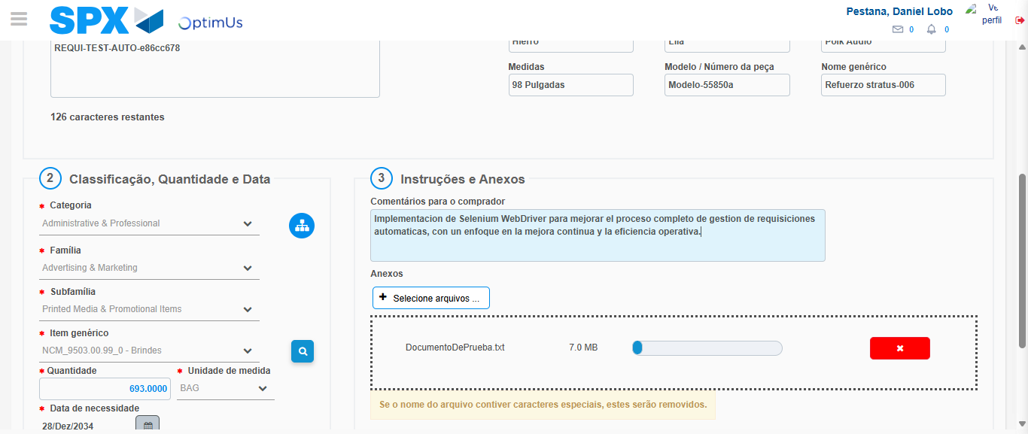Image file-name: QC_Testing-tc006_SPX_Dev5_Crear_Requisicion_Spot_Tipo_Cobro_Proyect_Urgent-1784214747453

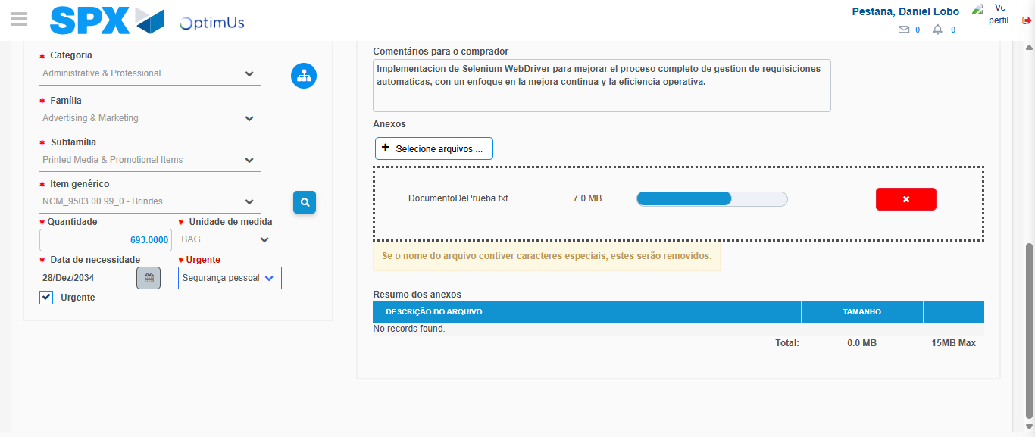Image file-name: QC_Testing-tc006_SPX_Dev5_Crear_Requisicion_Spot_Tipo_Cobro_Proyect_Urgent-1784214751515

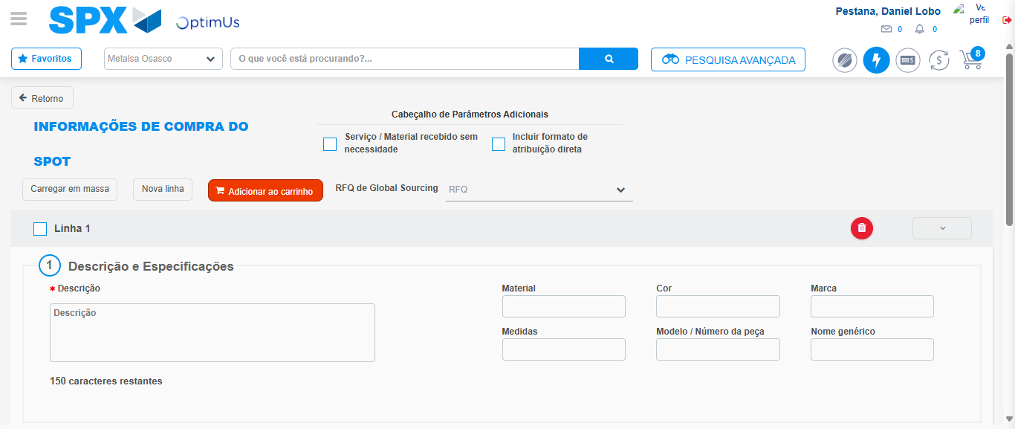Image file-name: QC_Testing-tc006_SPX_Dev5_Crear_Requisicion_Spot_Tipo_Cobro_Proyect_Urgent-1784214757933

Step 7 - Return to Main Page SPX : Return to Main Page SPX
Image file-name: QC_Testing-tc006_SPX_Dev5_Crear_Requisicion_Spot_Tipo_Cobro_Proyect_Urgent-1784214710823

Image file-name: QC_Testing-tc006_SPX_Dev5_Crear_Requisicion_Spot_Tipo_Cobro_Proyect_Urgent-1784214713371

Image file-name: QC_Testing-tc006_SPX_Dev5_Crear_Requisicion_Spot_Tipo_Cobro_Proyect_Urgent-1784214731292

Image file-name: QC_Testing-tc006_SPX_Dev5_Crear_Requisicion_Spot_Tipo_Cobro_Proyect_Urgent-1784214760210

Image file-name: QC_Testing-tc006_SPX_Dev5_Crear_Requisicion_Spot_Tipo_Cobro_Proyect_Urgent-1784214760394

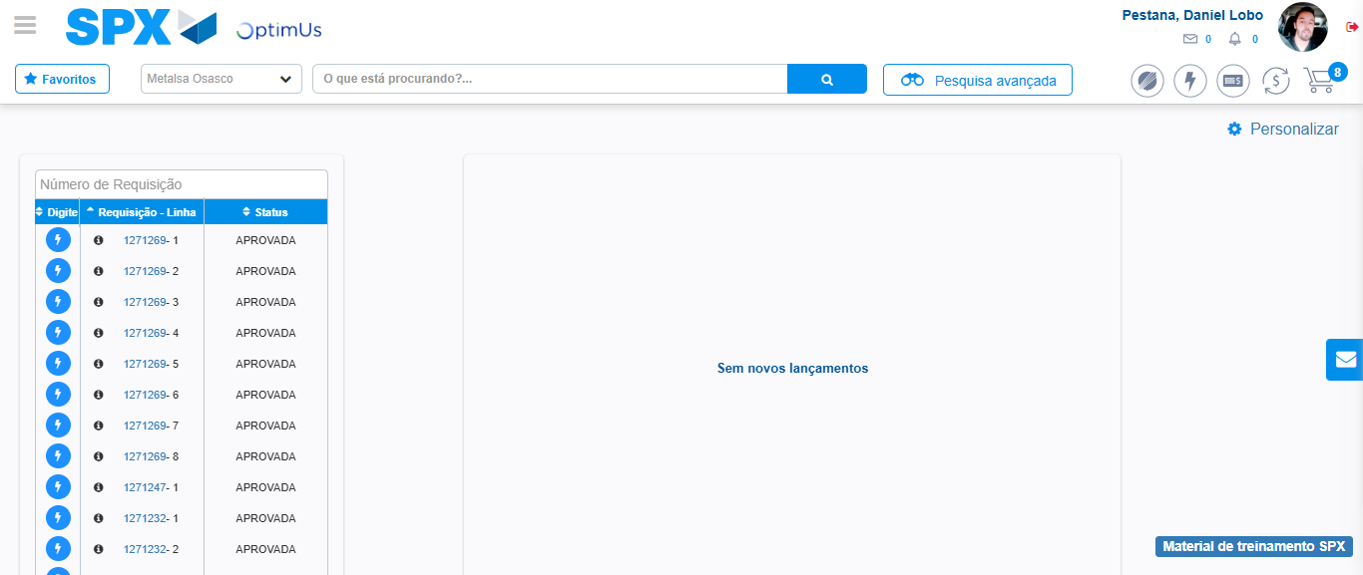Image file-name: QC_Testing-tc006_SPX_Dev5_Crear_Requisicion_Spot_Tipo_Cobro_Proyect_Urgent-1784214781518

Step 8 - Log Out : Log Out SPX
Image file-name: QC_Testing-tc006_SPX_Dev5_Crear_Requisicion_Spot_Tipo_Cobro_Proyect_Urgent-1784214781750

